Analog Out Noise:

internal vref

last 1000 counts

|  |  |  |  |
| --- | --- | --- | --- |
| Gain \ Ipix | 10uA | 40uA | 60uA |
| 1 | |  |  | | --- | --- | | Dark | 12.586 | | Ref | 12.857 | | Active | 13.296 | | |  |  | | --- | --- | | Dark | 46.053 | | Ref | 44.624 | | Active | 13.151 | | |  |  | | --- | --- | | Dark |  | | Ref |  | | Active |  | |
| 4 | |  |  | | --- | --- | | Dark |  | | Ref |  | | Active |  | | |  |  | | --- | --- | | Dark | 48.377 | | Ref | 48.692 | | Active | 16.175 | | |  |  | | --- | --- | | Dark |  | | Ref |  | | Active |  | |
| 8 | |  |  | | --- | --- | | Dark |  | | Ref |  | | Active |  | | |  |  | | --- | --- | | Dark | 47.261 | | Ref | 48.045 | | Active | 20.495 | | |  |  | | --- | --- | | Dark | 19.485 | | Ref | 19.019 | | Active | 17.955 | |

|  |  |  |
| --- | --- | --- |
|  |  |  |
|  |  |  |
|  |  | D/R saturation |

Analog Out Noise:

external vref *0.5

last 1000 counts

|  |  |  |  |
| --- | --- | --- | --- |
| Gain \ Ipix | 10uA | 40uA | 60uA |
| 1 | |  |  | | --- | --- | | Dark | 7.311 | | Ref | 6.835 | | Active | 6.598 | | |  |  | | --- | --- | | Dark | 29.426 | | Ref | 28.527 | | Active | 6.677 | | |  |  | | --- | --- | | Dark |  | | Ref |  | | Active |  | |
| 4 | |  |  | | --- | --- | | Dark |  | | Ref |  | | Active |  | | |  |  | | --- | --- | | Dark | 29.663 | | Ref | 28.125 | | Active | 11.42 | | |  |  | | --- | --- | | Dark |  | | Ref |  | | Active |  | |
| 8 | |  |  | | --- | --- | | Dark |  | | Ref |  | | Active |  | | |  |  | | --- | --- | | Dark | 28.648 | | Ref | 28.707 | | Active | 16.322 | | |  |  | | --- | --- | | Dark |  | | Ref |  | | Active |  | |

|  |  |  |
| --- | --- | --- |
|  |  |  |
|  |  |  |
|  |  |  |

Analog Out Noise:

GTM016AN V33D from Vref

external vref *0.5

last 1000 counts

|  |  |  |  |
| --- | --- | --- | --- |
| Gain \ Ipix | 10uA | 40uA | 60uA |
| 1 | |  |  | | --- | --- | | Dark | 8.199 | | Ref | 8.267 | | Active | 6.568 | | |  |  | | --- | --- | | Dark | 33.499 | | Ref | 33.603 | | Active | 6.695 | | |  |  | | --- | --- | | Dark |  | | Ref |  | | Active |  | |
| 4 | |  |  | | --- | --- | | Dark |  | | Ref |  | | Active |  | | |  |  | | --- | --- | | Dark | 33.044 | | Ref | 33.102 | | Active | 11.427 | | |  |  | | --- | --- | | Dark |  | | Ref |  | | Active |  | |
| 8 | |  |  | | --- | --- | | Dark |  | | Ref |  | | Active |  | | |  |  | | --- | --- | | Dark | 32.669 | | Ref | 33.545 | | Active | 16.459 | | |  |  | | --- | --- | | Dark |  | | Ref |  | | Active |  | |

|  |  |  |
| --- | --- | --- |
|  |  |  |
|  |  |  |
|  |  |  |

Analog Out Noise:

GTM016AN V33D from Vref

external vref *0.5

PAD_39 to 75kOhm parallel 100nF to GND

last 1000 counts

|  |  |  |
| --- | --- | --- |
| Ipix \ Gain | 1 | 4 |
| 2u | |  |  | | --- | --- | | Dark | 7.166 | | Ref | 7.07 | | Active | 6.634 | | |  |  | | --- | --- | | Dark | 6.564 | | Ref | 6.599 | | Active | 10.582 | |
| 5u | |  |  | | --- | --- | | Dark | 19.173 | | Ref | 19.396 | | Active | 6.568 | | |  |  | | --- | --- | | Dark | 20.441 | | Ref | 20.371 | | Active | 10.597 | |
| 10u | |  |  | | --- | --- | | Dark | 39.727 | | Ref | 39.391 | | Active | 6.504 | | |  |  | | --- | --- | | Dark | 41.864 | | Ref | 42.302 | | Active | 10.887 | |
| 40u | |  |  | | --- | --- | | Dark | 220.133 | | Ref | 224.349 | | Active | 6.77 | | |  |  | | --- | --- | | Dark | 216.537 | | Ref | 223.037 | | Active | 12.164 | |

|  |  |
| --- | --- |
|  |  |
|  |  |
|  |  |
|  |  |

Vbandgap noise:

last 1000 counts

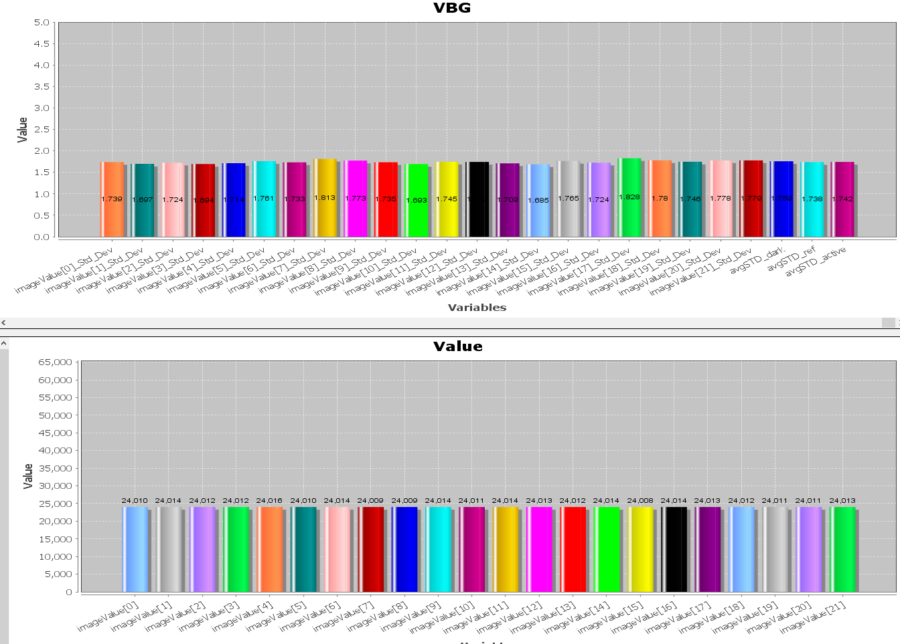

Ipix noise:

external vref *0.5

last 1000 counts

|  |  |
| --- | --- |
| Ipix \ Gain | 4 |
| 10u | |  |  | | --- | --- | | Active | 6.38 | |
| 20u | |  |  | | --- | --- | | Active | 12.205 | |
| 40u | |  |  | | --- | --- | | Active | 24.955 | |

|  |  |
| --- | --- |
| Ipix \ Gain | 4 |
| 10u |  |
| 20u |  |
| 40u |  |

system test

Vref * ¼ to Ext. ADC with ADA4891

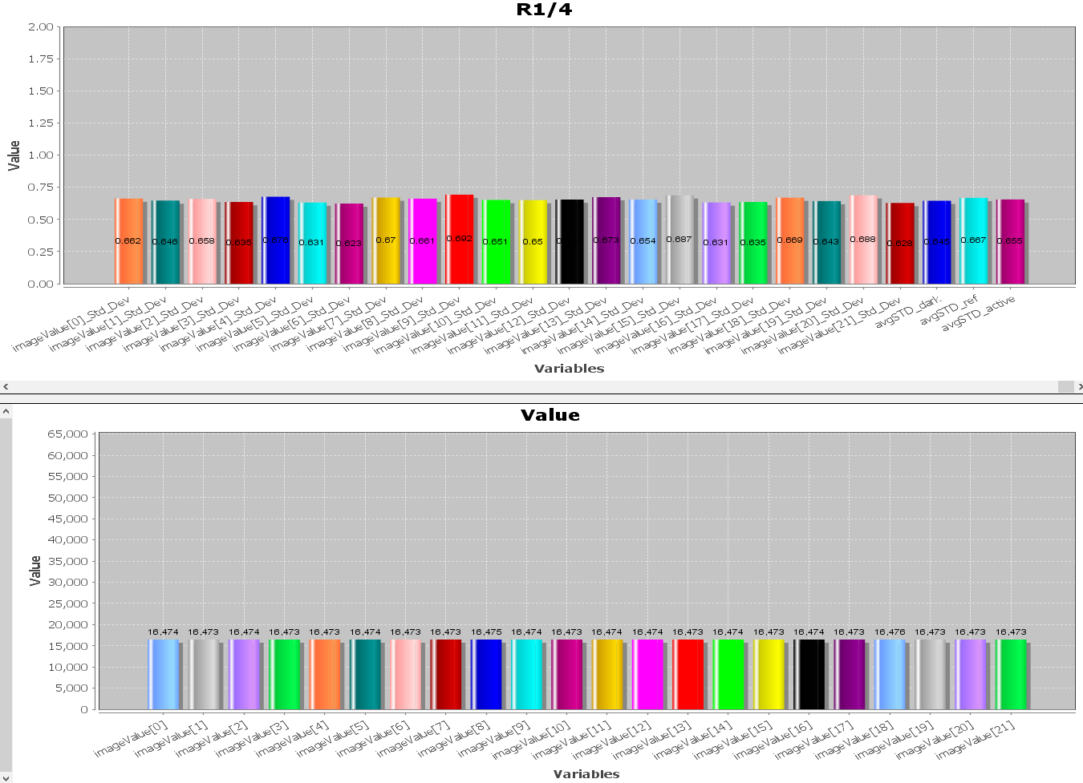

Vref * ½ to Ext. ADC with ADA4891

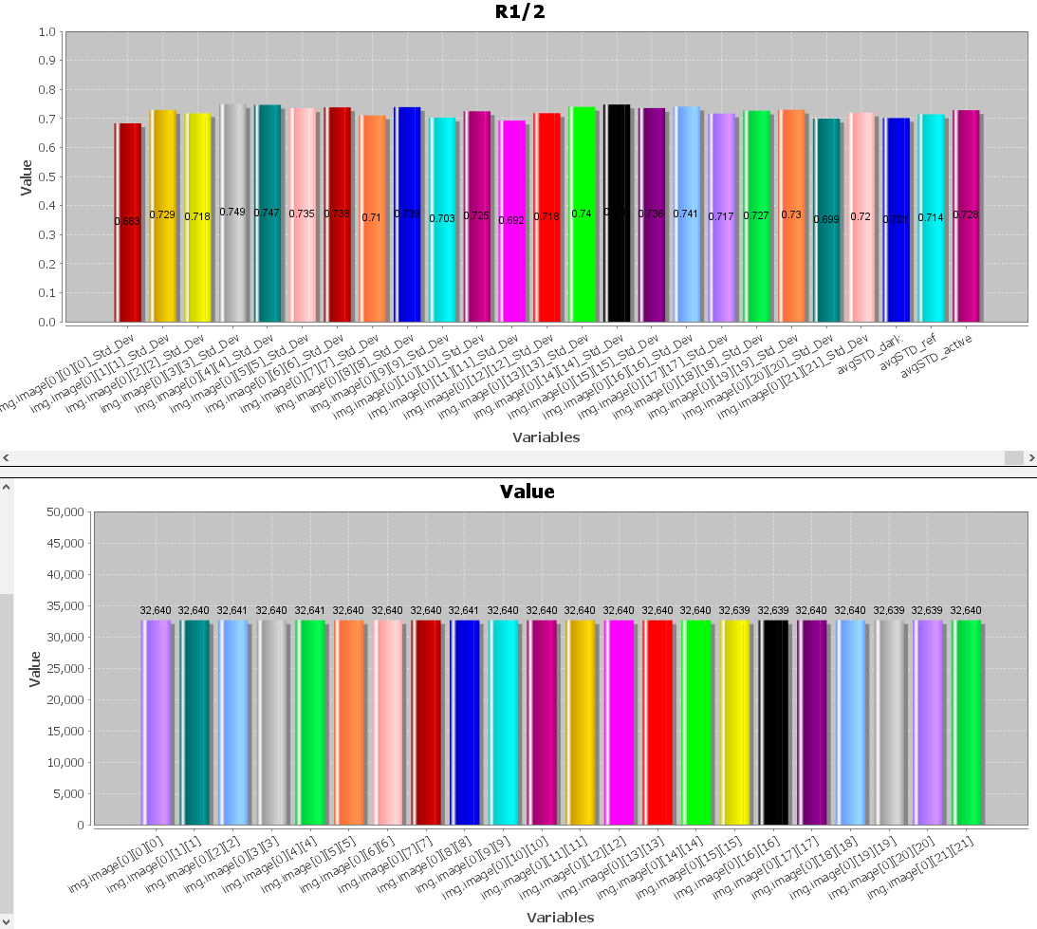

system test

ADP150 Vout * 1/2 to Ext. ADC with ADA4891 (without GTM016AN)

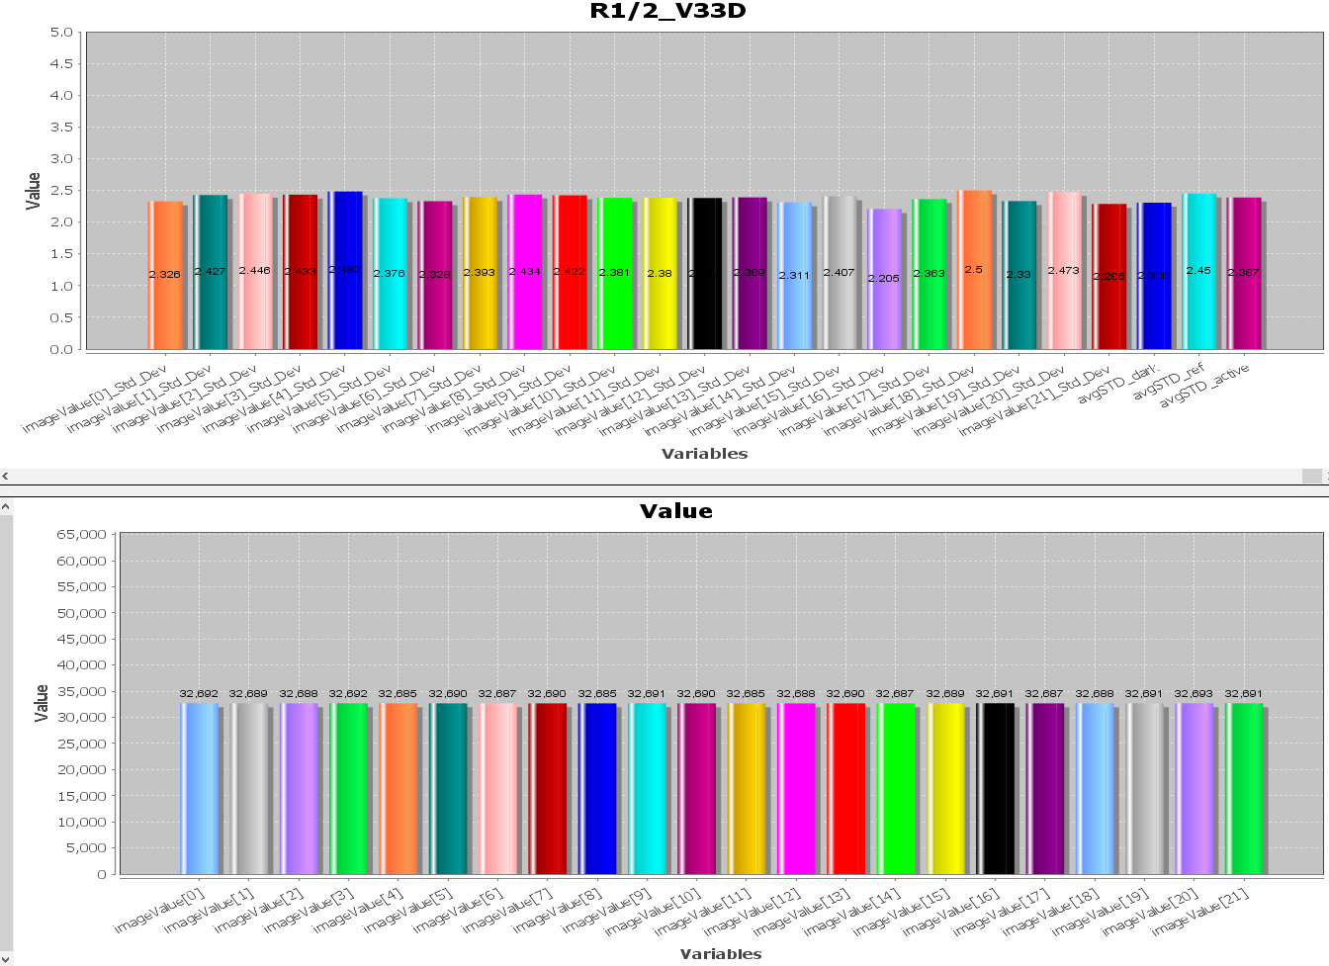

ADP150 Vout * 1/2 to Ext. ADC with ADA4891 (with GTM016AN)

